
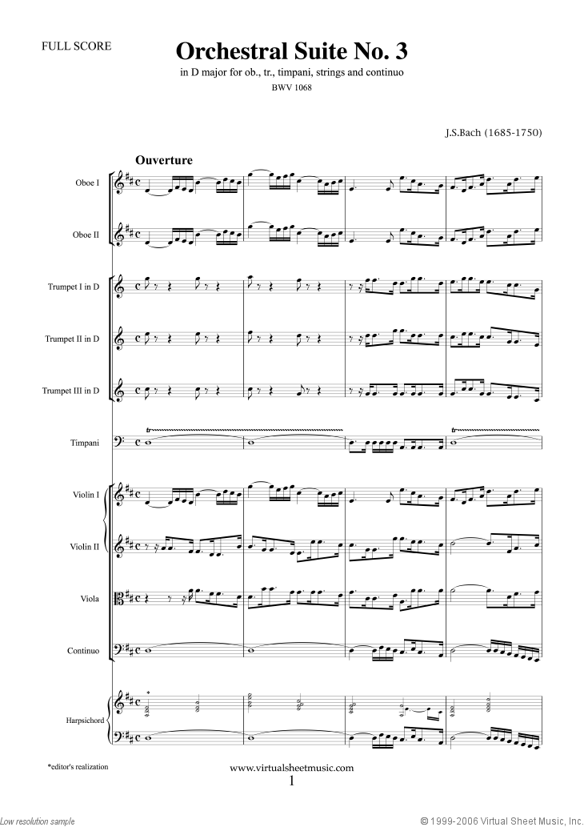
Type here
Type here

Type here

MY PICTURE
One Page Profile for
Type name here

