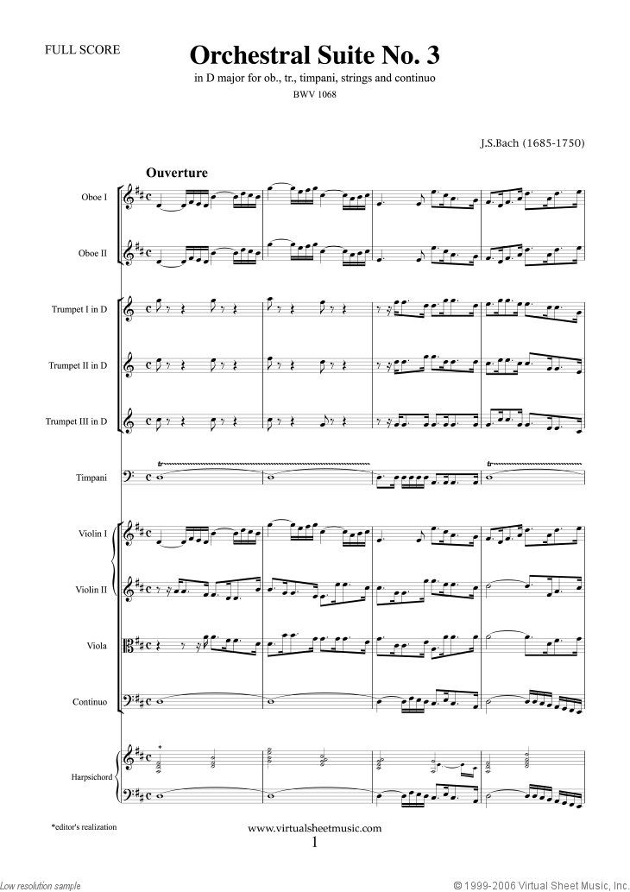

Type here

Type here

Type here

MY PICTURE

**One Page Profile** for

Type name here